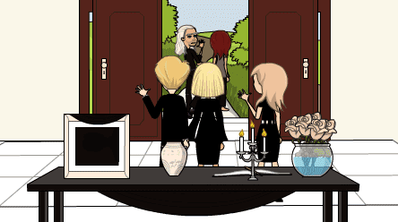
Entrance Area
Int. Location
Story
Does the location meet the scene requirements?
Does the location fit the Director’s tone?
Does the setting fit the time period and story setting?
Is the view from any windows in frame good? |  | Ask neighbour to relocate horse float.
Is set dressing and/or props needed? |  | Console table, Urn, Photograph, Black Chiffon Scarf, Book, Gold Pen, Candles, Silver Candelabra, Champagne Roses, Rose Bowl, and Black Tablecloth.
Sight
If a wide shot is required, is this shot achievable? |  | Shoot from Sala area (move day bed out from wall).
If a 360 shot is required, is this shot achievable? |  | It’s achievable, but not planned at this stage.
Are there any problematic, visual elements in the frame?
Does the cast, crew and gear fit inside the location? Is there enough space?
Any sunlight considerations? |  | In the morning (shoot no later than 10am).
Lighting
Is natural light available?
Is there space to add lighting if required?
If required, what additional lights will you need? |  | LCD Spotlight on bottom step angled up towards entrance doors, and a second LCD spotlight placed in hallway next to study facing towards entrance doors.
Sound
Can you turn off heating, ventilation and/or air conditioning units?
Can you turn off any noisy appliances, machines or refrigerators?
Can you record clean dialogue?
Do you need to dampen echoes in the space?
Any pedestrian, vehicle, train, train track, overhead airplane, subway noise concerns?

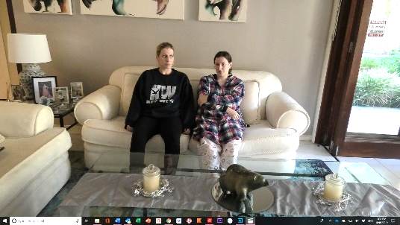
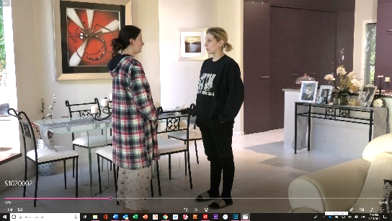
Morning Room
Ext. Location
Story
Does the location meet the scene requirements?
Does the location fit the Director’s tone?
Does the setting fit the time period and story setting?
Is the view from any windows in frame good?
Is set dressing and/or props needed? |  | Remove dining chairs, relocate console table to entrance area. Push dining table against wall, add a white tablecloth and wake food. Relocate black study table from media room and place where the console table used to be, setup bar. Swap out photographs with Rochester family photographs.
Sight
If a wide shot is required, is this shot achievable?
If a 360 shot is required, is this shot achievable? |  | It’s achievable, but not planned at this stage.
Are there any problematic, visual elements in the frame?
Does the cast, crew and gear fit inside the location? Is there enough space?
Any sunlight considerations? |  | In the morning (shoot no later than 10am).
Lighting
Is natural light available?
Is there space to add lighting if required?
If required, what additional lights will you need? |  | LCD spotlight angled up to ceiling hidden behind kitchen bench. 2 x personal LCD lights placed in front of talent (outside of frame).
Sound
Can you turn off heating, ventilation and/or air conditioning units?
Can you turn off any noisy appliances, machines or refrigerators?
Can you record clean dialogue?
Do you need to dampen echoes in the space?
Any pedestrian, vehicle, train, train track, overhead airplane, subway noise concerns?

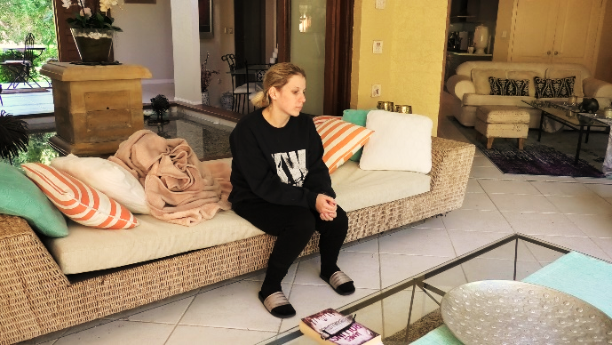
Sala
Ext. Location
Story
Does the location meet the scene requirements?
Does the location fit the Director’s tone?
Does the setting fit the time period and story setting?
Is the view from any windows in frame good?
Is set dressing and/or props needed? |  | QC’s case file and paperwork.
Sight
If a wide shot is required, is this shot achievable?
If a 360 shot is required, is this shot achievable? |  | It’s achievable, but not planned at this stage.
Are there any problematic, visual elements in the frame?
Does the cast, crew and gear fit inside the location? Is there enough space?
Any sunlight considerations?
Lighting
Is natural light available?
Is there space to add lighting if required?
If required, what additional lights will you need?
Sound
Can you turn off heating, ventilation and/or air conditioning units?
Can you turn off any noisy appliances, machines or refrigerators?
Can you record clean dialogue?
Do you need to dampen echoes in the space?
Any pedestrian, vehicle, train, train track, overhead airplane, subway noise concerns?

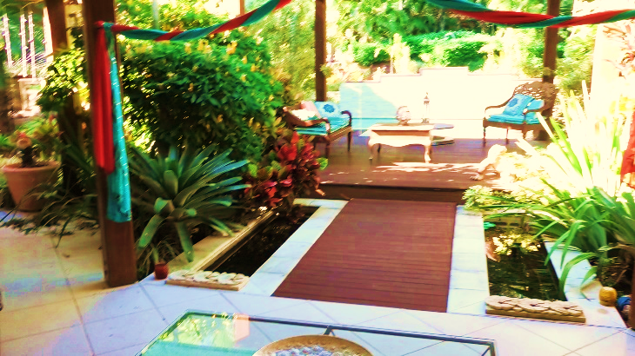
Pergola
Ext. Location
Story
Does the location meet the scene requirements?
Does the location fit the Director’s tone?
Does the setting fit the time period and story setting?
Is the view from any windows in frame good?
Is set dressing and/or props needed? |  | QC’s case file and paperwork.
Sight
If a wide shot is required, is this shot achievable?
If a 360 shot is required, is this shot achievable? |  | It’s achievable, but not planned at this stage.
Are there any problematic, visual elements in the frame?
Does the cast, crew and gear fit inside the location? Is there enough space?
Any sunlight considerations?
Lighting
Is natural light available?
Is there space to add lighting if required?
If required, what additional lights will you need?
Sound
Can you turn off heating, ventilation and/or air conditioning units?
Can you turn off any noisy appliances, machines or refrigerators?
Can you record clean dialogue?
Do you need to dampen echoes in the space?
Any pedestrian, vehicle, train, train track, overhead airplane, subway noise concerns?

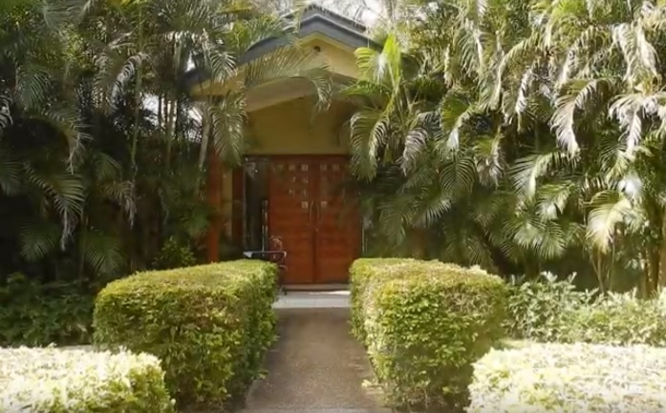
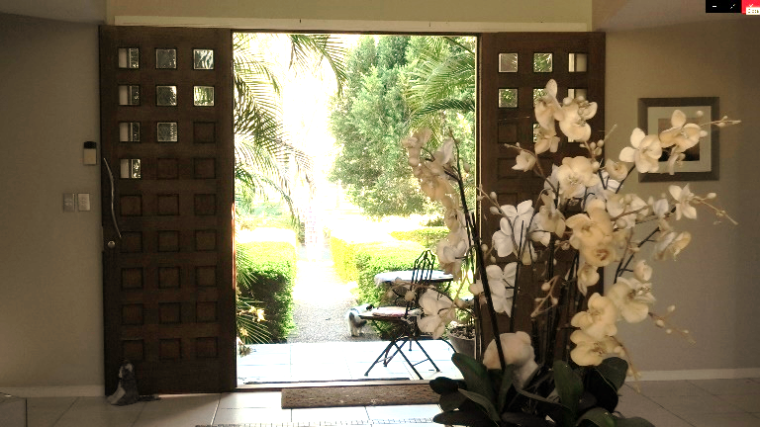
Front Path
Ext. Location
Story
Does the location meet the scene requirements?
Does the location fit the Director’s tone?
Does the setting fit the time period and story setting?
Is the view from any windows in frame good?
Is set dressing and/or props needed? |  | Remove café table and chairs.
Sight
If a wide shot is required, is this shot achievable?
If a 360 shot is required, is this shot achievable? |  | It’s achievable, but not planned at this stage.
Are there any problematic, visual elements in the frame?
Does the cast, crew and gear fit inside the location? Is there enough space?
Any sunlight considerations?
Lighting
Is natural light available?
Is there space to add lighting if required?
If required, what additional lights will you need?
Sound
Can you turn off heating, ventilation and/or air conditioning units?
Can you turn off any noisy appliances, machines or refrigerators?
Can you record clean dialogue?
Do you need to dampen echoes in the space?
Any pedestrian, vehicle, train, train track, overhead airplane, subway noise concerns?

Cast + Crew Facilities
Int. & Ext. Locations
Is there enough parking for Cast and Crew? |  | A half-acre front paddock will be used for parking.
Are there enough bathrooms for Cast and Crew? |  | 3 dedicated bathrooms for 12 cast and crew.
Is there a dedicated quiet space for Cast and Crew? |  | Two-(2) spaces have been assigned for cast and crew, externally the BBQ hut, which is also the temporary catering area, as well as a separate internal lounge room.
Is there a dedicated quiet space for Equipment and recharging? |  | The house study will be use$Type equation here.$d as the camera battery recharging area, and scratch file SD dump.
Is there a dedicated space and accessible power outlets for Hair & Makeup preparation? |  | The Media Room will be used for Hair, Makeup and Wardrobe.
Will the location be too hot or too cold? Is there temperature control? |  | All internal location areas can be climate controlled.
Will rain (or the sound of the rain) have an impact on shooting? |  | The sound of rain on the metal roof will have an impact on recording.
Has the location owner signed a Location Releases Form and/or Lease Contract?
Is the location covered by Insurance? |  | Allianz policy in place.

