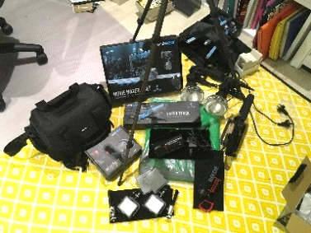
Equipment
Checklist
 | VIDEO |  | QUICK FIX KIT
 | Panasonic 4K Camcorder |  | 10 x AAA Batteries
 | 3 x Panasonic Batteries |  | 10 x AA Batteries
 | Dual Panasonic Wall Battery Charger |  | 2 x iOS Cables (and USB plugs)
 | Canon PowerShot S120 Digital Camera |  | 2 x Android Cables (and USB plugs)
 | 3 x Canon Batteries |  | Blue Tac
 | Canon Wall Battery Charger |  | Sticky Tape
 | 3 x SLIK Tripods |  | Safety Pins (various sizes)
 | SanDisk Extreme Pro 128GB |  | Lens Cleaning Cloth
 | GripGear Movie Maker 2 Set |  | Hairbrush, Hair Pins & Bands
 | GripGear Micro Dolly |  | Makeup (BB Cream, Powder, Blush and Gloss) and Brushes
 | GripGear Extra Track |  | Tissues
 | GripGear Remote Control |  | Makeup Wipes
 | Clamps

 | AUDIO |  | LIGHTING
 | Rode Shotgun Microphone (attaches to Panasonic 4K Camcorder) |  | 2 x Neewer 5400k Dimmable LED Video Light Lamp
 | Takstar Shotgun Microphone (attaches to iPad with HD Audio Recording software) |  | 2 x mini Tripods (used with LED Video Light Lamps)
 | iPad with HD Audio Recording software |  | 2 x Spotlights (with reflectors)

MISCELLANEOUS
10 plug Extension Board
10m Extension Cord
ACER Laptop
Clapper Board with Chalk Markers

Props
Checklist

DAY 1 (Saturday – 18.05.2019)
Certificate (rolled up and tied with a red ribbon)
Champagne coloured Roses tied in a posy style with a champagne ribbon
Hand-held SOLD sign
Swaddled Baby Doll
Baby Bottle containing milk
Award Plaque

DAY 2 (Saturday – 25.05.2019)
Two medium paper coffee cups
QC’s case file
Clipboard
Paperwork
Handkerchief

DAY 3 (Sunday – 26.05.2019)
Handcuffs
Scotch Glass (containing iced tea)

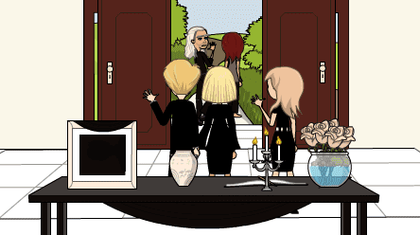
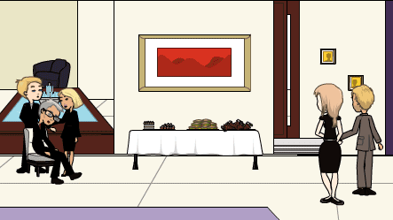
Set Design
Checklist

 |  | ENTRANCE |  | MORNING ROOM |  | SALA |  | PERGOLA |  | FRONT PATH
 |  | Black Console Table |  | Bar: |  | Glass Coffee Table: |  | Wooden Table: |  | N/A
 |  | Black Chiffon Scarf |  | - Bottle Opener |  | - Green Runner |  | - Green Tablecloth
 |  | Black Tablecloth |  | - Champagne Bucket |  | - Silver Platter |  | - Silver Platter
 |  | Candelabra |  | - Champagne Bottles |  | Scatter Cushions |  | Scatter Cushions
 |  | Candles |  | - Cocktail Glasses
 |  | Champagne Roses |  | - Ice
 |  | Condolence Book |  | - Red Wine Bottles
 |  | Gold Pen |  | - Scotch Glasses
 |  | Rose Bowl |  | - Whisky Bottle
 |  | Silver Photograph Frame |  | - Wine Glasses
 |  | Urn |  | Buffett:
 |  |  |  | - White Tablecloth
 |  |  |  | - Sandwiches
 |  |  |  | - Tea Cakes
 |  |  |  | - Napkins
 |  |  |  | - White Plates
 |  |  |  | - 2 x Platters
 |  |  |  | - 3 Tier Cake Stand
 |  |  |  | Chair Pillow
 |  |  |  | Coffee Table:
 |  |  |  | - Bear Statue
 |  |  |  | - 2 x Candles
 |  |  |  | - Circular Mirror

Wardrobe
Checklist

DAY 1 (Saturday – 18.05.2019)

 |  | 21 YEARS |  | 25 YEARS |  | 27 YEARS |  | 29 YEARS |  | 40 YEARS
MORGAN |  | Black Mortarboard Hat |  | White Dress |  | Coloured Top |  | Pale Dress |  | White Shirt
 |  | Black Cloak |  | White Veil |  | Dark Short Skirt |  | Flat Shoes |  | Black Skirt
 |  | Pale Dress |  | Tiara |  | Converses |  |  |  | Black Cloak
 |  | High Heels |  |  |  |  |  |  |  | Good Jewellery
JOHN |  | Dark Suit |  | Black Tux |  | Short Sleeved Shirt |  | Cream Jumper |  | Dark Suit
 |  | Coloured Shirt |  | White Shirt |  | Jeans |  | Chinos |  | White Shirt
 |  | Tie |  | Cufflinks |  | Casual Shoes |  | Casual Shoes |  | Tie
 |  | Business Shoes |  | Bow Tie |  |  |  |  |  | Business Shoes
 |  |  |  | Business Shoes
GWEN |  | Black Tee |  | Bridesmaid Dress |  | Pale Top |  | Pale Tee |  | Floral Dress
 |  | Black Skirt |  | High Heels |  | Shorts |  | Smart Slacks |  | Shawl
 |  | Black Belt |  |  |  | Converses |  | Flat Shoes |  | Wedges
 |  | Flat Shoes |  |  |  |  |  |  |  | Cheap Jewellery

DAY 2 (Saturday – 25.05.2019)

 | MORGAN (Flashback) |  | MORGAN (Wake) |  | GWEN (Flashback) |  | GWEN (Wake) |  | ASTARA
 | White Shirt |  | Black Dress |  | Floral Dress (too big) |  | Black Shirt |  | Flowing Dark Gown
 | Black Skirt |  | Black High Heels |  | Shawl |  | Black Skirt |  | Subdued Bling Cross
 | Black Cloak |  | Gold Jewellery |  | Wedges |  | Black Wedges |  | Sandals
 | Good Jewellery |  |  |  | Cheap Jewellery |  | Cheap Jewellery

DAY 3 (Sunday – 26.05.2019)

 | MORGAN |  | GWEN |  | ASTARA |  | DETECTIVE JARRETT
 | Black Dress |  | Black Shirt |  | Flowing Dark Gown |  | Long Overcoat
 | Black High Heels |  | Black Skirt |  | Subdued Bling Cross |  | White Shirt
 | Gold Jewellery |  | Black Wedges |  | Sandals |  | Tie
 |  |  | Cheap Jewellery |  |  |  | Suit Pants
 |  |  |  |  |  |  | Business Shoes
 | COURTNEY |  | MAX |  | JOHN |  | NATALIE & BARB
 | Black Top |  | Dark Suit |  | Dark Suit |  | Dark Smart Clothing
 | Black Tailored Pants |  | White Shirt |  | White Shirt |  | Subdued Jewellery
 | High Heels |  | Dark Tie |  | Dark Tie
 | Tiffany Jewellery |  | Business Shoes |  | Business Shoes

