Activity 4.1 Storyboard

Scene 3: Courtney watching TV (Interior Lounge Room) Page 1

Shot Number: 3-01 Shot Type: MLS
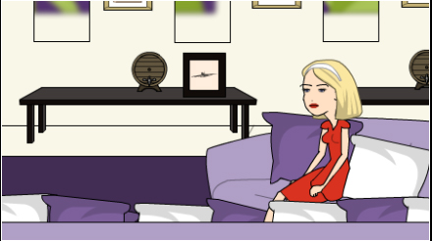

Description: Courtney watches television.
Sound: Television program in background.
Production Notes: Make sure that this shot type is different from the shot type at the end of Camera Competency Exercise #2.
Shot Duration: 3 seconds

Shot Number: 3-02 Shot Type: CU
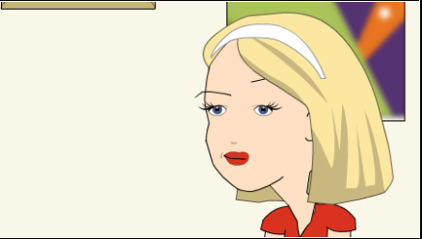
Description: Courtney thinking about getting a drink.
Sound: Television program in background.
Production Notes: Tell C to exaggerate thinking.
Shot Duration: 5 seconds

Shot Number: 3-03 Shot Type: WS
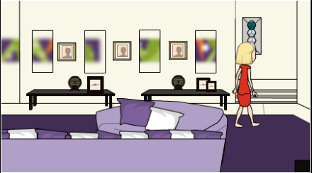
Description: Courtney gets up and turns off the television. She then drops the remote control onto the ottoman and then walks out of the room.
Sound: Television program in background stopping, remote control dropping, and footsteps.
Production Notes: -
Shot Duration: 10 seconds

Shot Number: 3-04 Shot Type: LS
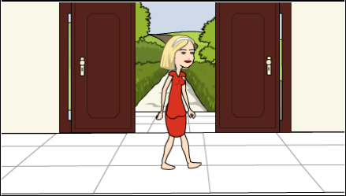
Description: Courtney walks across entrance way and then down the steps into the Morning Room/Kitchen.
Sound: Footsteps and train of dress dragging.
Production Notes: Show off train of dress as C walks through hallway.
Shot Duration: 5 seconds

Scene 4: Courtney making a cappuccino (Interior Morning Room & Kitchen) Page 2

Shot Number: 4-01 Shot Type: WS
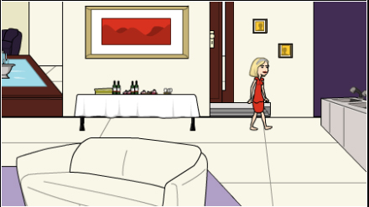

Description: Courtney walks down steps and turns left into kitchen.
Sound: Footsteps.
Production Notes: Optional shot (may leave in, out or shorten in final edit)
Shot Duration: 3 seconds

Shot Number: 4-02 Shot Type: LS
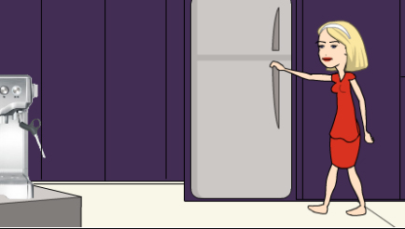

Description: Courtney walks to fridge, opens door and looks inside.
Sound: Fridge door opening.
Production Notes: Tell Courtney to swing arms as she walks.
Shot Duration: 5 seconds

Shot Number: 4-03 Shot Type: CU
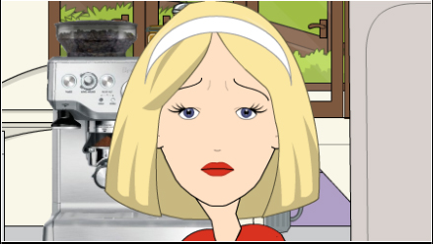

Description: Courtney is not impressed with fridge contents (from inside fridge perspective).
Sound: Hum of fridge in background.
Production Notes: Exaggerate disappointment.
Shot Duration: 10 seconds

Shot Number: 4-04 Shot Type: LS
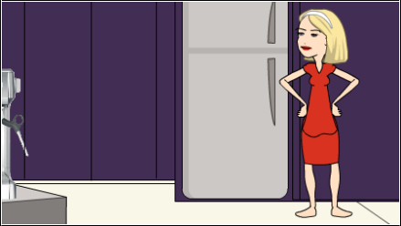

Description: Courtney closes fridge door and turns around facing the sink and has a think.
Sound: Fridge door closing.
Production Notes: Direct Courtney to look first at lemons in jar, then sink, and then at the coffee machine.
Shot Duration: 6 seconds

Scene 4 (Interior Morning Room & Kitchen) Page 3

Shot Number: 4-05 Shot Type: MCU
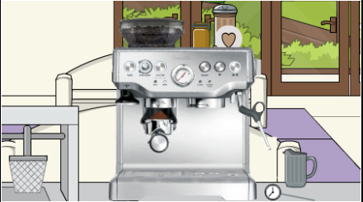

Description: Coffee machine on bench.
Sound: Hallelujah (short) sound.
Production Notes: Loud to surprise audience.
Shot Duration: 3 seconds

Shot Number: 4-06 Shot Type: LS
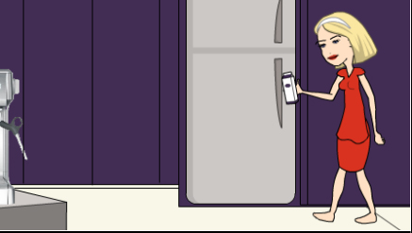

Description: Courtney nods and reopens the fridge and retrieves a milk carton.
Sound: Fridge door opening and shutting.
Production Notes: -
Shot Duration: 6 seconds

Shot Number: 4-07 Shot Type: WS
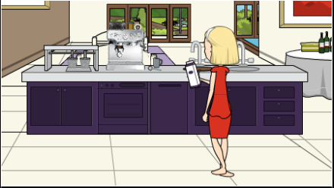

Description: Courtney walks to coffee machine and places milk on the bench on its right side.
Sound: Footsteps, milk being placed onto bench.
Production Notes: Quick transition shot.
Shot Duration: 2 seconds

Shot Number: 4-08 Shot Type: CU
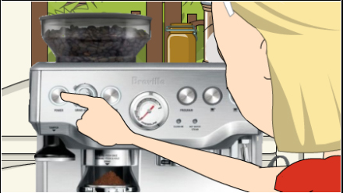

Description: Courtney turns coffee machine on.
Sound: Coffee machine start-up sound.
Production Notes: -
Shot Duration: 4 seconds

S4 - Morning Room/Kitchen Page: 4

Shot Number: 4-09 Shot Type: WS
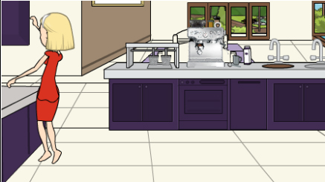

Description: Courtney retrieves a cup and saucer from overhead cupboard to her left, and a teaspoon from draw below. Places cup, saucer and teaspoon on the bench to the left side of the coffee machine.
Sound: Cupboard and draw doors opening, placement of cup on bench.
Production Notes: Direct Courtney to go up onto tippy toes.
Shot Duration: 20 seconds

Shot Number: 4-10 Shot Type: MS
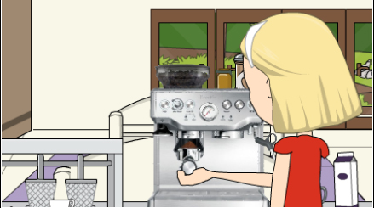

Description: Courtney’s hand taking out Portafilter, wiping it and then reinserting Portafilter under the coffee bean grinder. Pushing it in and allowing the filter to fill with ground coffee.
Sound: Metallic release sound.
Production Notes: -
Shot Duration: 6 seconds

Shot Number: 4-11 Shot Type: CU
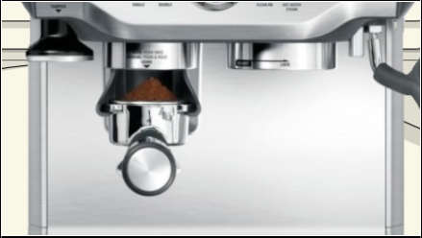

Description: Ground coffee falling into filter.
Sound: Metallic click and grinding coffee noise.
Production Notes: -
Shot Duration: 8 seconds

Shot Number: 4-12 Shot Type: MS
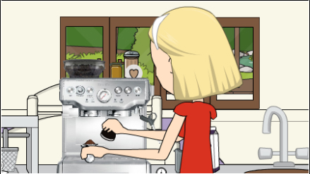

Description: Courtney pulls out Portafilter from coffee bean grinder and places it on the bench to the right of the coffee machine.
Sound: Metallic sound when pulled out and again when placed on bench.
Production Notes: Quick transition shot.
Shot Duration: 2 seconds

S4 - Morning Room/Kitchen Page: 5

Shot Number: 4-13 Shot Type: CU
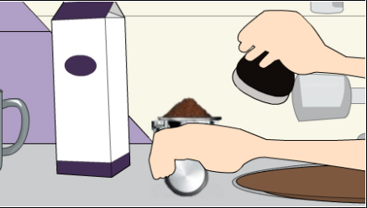

Description: Courtney tamps down ground coffee.
Sound: Squishy and pressure sound.
Production Notes: Put a towel underneath tamping.
Shot Duration: 8 seconds

Shot Number: 4-14 Shot Type: MS
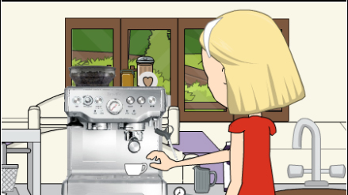

Description: Courtney secures Portafilter into group head and places cup underneath both spouts.
Sound: Clunk sound.
Production Notes: Quick transition shot.
Shot Duration: 2 seconds

Shot Number: 4-15 Shot Type: CU
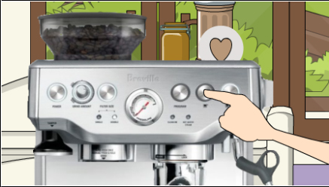

Description: Courtney pushes 1cup option on coffee machine.
Sound: Coffee processing sound.
Production Notes: Quick transition shot.
Shot Duration: 2 seconds

Shot Number: 4-16 Shot Type: MS
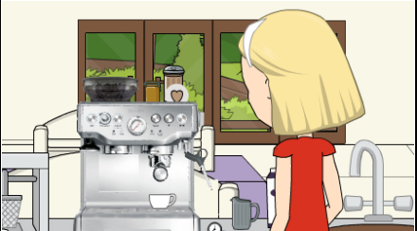

Description: Courtney watches coffee poured.
Sound: Coffee pouring out of spouts.
Production Notes: -
Shot Duration: 4 seconds

S4 - Morning Room/Kitchen Page: 6

Shot Number: 4-17 Shot Type: CU
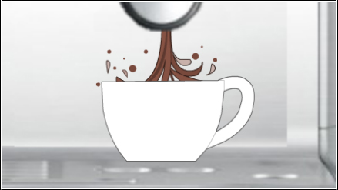

Description: Coffee pouring into cup under group head.
Sound: Coffee pouring out of spouts.
Production Notes: Shouldn’t be centred (move to left of frame to shoot).
Shot Duration: 5 seconds

Shot Number: 4-18 Shot Type: MS
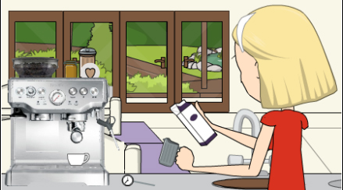

Description: Courtney puts tamper back into position on machine. She picks up milk carton, opens it and pours milk into metal jug (ensure temperature gauge is attached) and places steamer into jug.
Sound: Lots of metallic sounds and milk being poured.
Production Notes: -
Shot Duration: 15 seconds

Shot Number: 4-19 Shot Type: CU
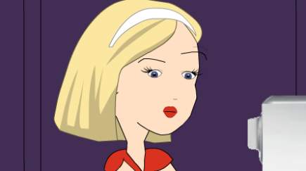

Description: Cutaway to Courtney concentrating (during milk steaming process).
Sound: N/A
Production Notes: -
Shot Duration: 3 seconds

Shot Number: 4-20 Shot Type: MS
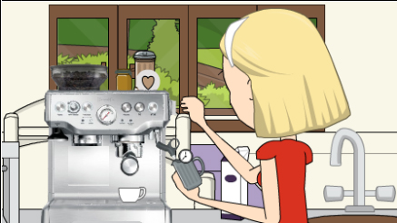

Description: Courtney steams milk.
Sound: Steamer processing.
Production Notes: Insert 4-19 shot cut-away half-way through this shot in post-edit.
Shot Duration: 40 seconds

S4 - Morning Room/Kitchen Page: 7

Shot Number: 4-21 Shot Type: CU (continuous filming)
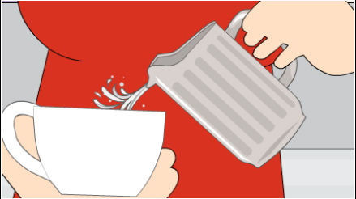

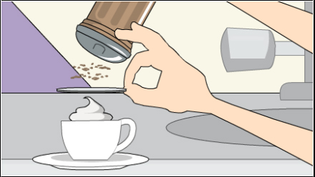

Description: Courtney pours steamed milk into cup.
Sound: Milk pouring into cup.
Production Notes: -
Shot Duration: 10 seconds

Description: Courtney shaking chocolate over design template of cappuccino and grabs saucer, placing it underneath cup.
Sound: Dusting and saucer hitting bench.
Production Notes: -
Shot Duration: 18 seconds

Shot Number: 4-22 Shot Type: CU

Description: Close up of perfect cappuccino.
Sound: Hallelujah (long) sound.
Production Notes: Must look perfect!
Shot Duration: 8 seconds

Shot Number: 4-23 Shot Type: MS
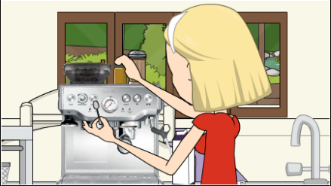

Description: Courtney picks up teaspoon, retrieves honey jar from top of machine, opens jar. Scoops out a teaspoon of honey.
Sound: Metallic sounds on glass jar.
Production Notes: Show off honey in glass jar.
Shot Duration: 10 seconds

S4 - Morning Room/Kitchen Page: 8

Shot Number: 4-24 Shot Type: CU
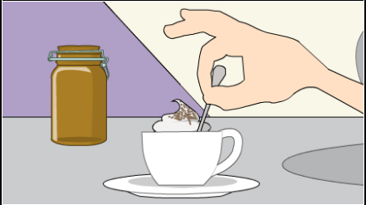

Description: Courtney stirs cup with spoon and honey.
Sound: Stirring metallic sound.
Production Notes: Insert 4-25 shot half-way through this shot.
Shot Duration: 10 seconds

Shot Number: 4-25 Shot Type: CU

Description: Cutaway to Courtney smiling (whilst stirring cup).
Sound: N/A
Production Notes: Courtney will need a lot of direction here.
Shot Duration: 3 seconds

Shot Number: 4-26 Shot Type: MS
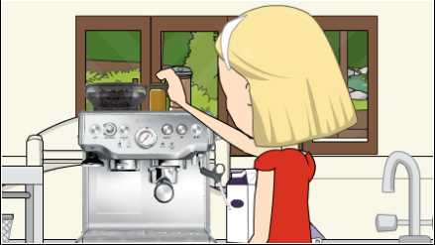

Description: Courtney rinses spoon in sink, and places honey back on top of the coffee machine. She turns off the coffee machine.
Sound: Water running, metal hitting sink. Glass jar hitting top of coffee machine. Coffee machine turning on.
Production Notes: -
Shot Duration: 10 seconds

Shot Number: 4-27 Shot Type: MCU
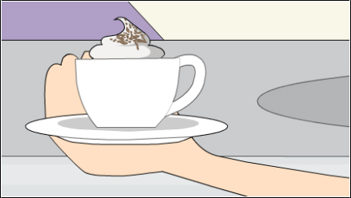

Description: Courtney picks up the cappuccino.
Sound: N/A
Production Notes: Quick transition shot.
Shot Duration: 2 seconds

S4 - Morning Room/Kitchen Page: 9

Shot Number: 4-28 Shot Type: MLS
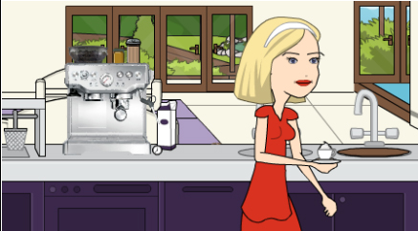

Description: Courtney carrying cappuccino walks out of the kitchen.
Sound: Footsteps.
Production Notes: -
Shot Duration: 3 seconds

Shot Number: 4-29 Shot Type: LS
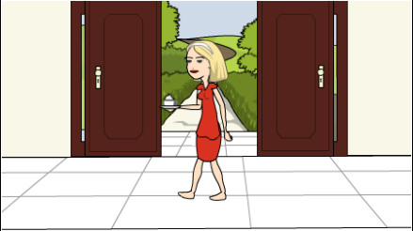

Description: Courtney walks across entrance way and then down the steps into the Media Room carrying cappuccino.
Sound: Footsteps.
Production Notes: Slow down walk along hallway.
Shot Duration: 10 seconds

